Fishes

Lesson 17

Characteristics
- Fishes are aquatic; cold blooded vertebrates
- Their body is divisible into head, trunk and tail. Neck is absent.
- It has a spindle shaped body. It is helpful in swimming
- The body is covered by scales. They are placoid scales, cycloid scales, ctenoid scales, ganoid scales etc
- Respiration is by gills. Gills are the extensions of the pharynx. In the elasmobranches fishes, the gills will open separate. In bony fishes the gill slits are covered by operculum
- On the head a pair of nostrils are present internal nostril are absent. In Dipnoi Internal nostrils are present
- On the head a pair of eyes is present.
- On the lateral sides of the body LATERAL LINE SENSE organs are present. They detect the pressure changes of water
- The body shows paired and unpaired fins. Pelvic and pectoral fins are paired. Dorsal and ventral fins are unpaired. They maintain balance in water. They are useful for locomotion
- The digestive system is well developed. In the intestine of shark scroll valve Is present. The nervous system contains brain and spinal cord. Brain is small & it will not occupy the entire cranial cavity
- 10 pairs of cranial nerves are present
- Kidneys are mesonephric.
- Urinary bladder is absent.
- The skeleton of some fishes is made by cartilage. They are called cartilage fishes. In some fishes the skeleton is made by bone. They are called bony fishes
- In some fresh water fishes accessory respiratory organs are present. They will take up aerial respiration.
- Sexes are separate. In male sharks claspers are present.
- Many fishes are oviparous. Some fishes are viviparous.
- In the development of fishes amnion is not developed. Hence these animals are called anamniotes.

PHYLOGENETIC RELATIONSHIPS
Fishes are members of the chordate subphylum Vertebrata; thus, they have vertebrae that surround their spinal cord and provide the primary axial support. They also have a skull that protects the brain.

Recent cladistic analysis of vertebrate evolution indicates that a group of fishes called hag-fishes are the most primitive vertebrates known (living or extinct). Making a connection between this lineage and other vertebrates depends on the analysis of two key vertebrate characteristics, the brain and bone.
Chinese researchers have recently unearthed the oldest alleged vertebrate fossils a small, lancelet- shaped animal that has characteristics that suggest an active, predatory lifestyle. A brain is present that would have processed sensory information from the pair of eyes that are seen in fossils. Muscle blocks along the body wall suggest an active swimming existence. This evidence means that these 530 million-year-old animals located prey by sight and then pursued it through prehistoric seas.
The origin of bone in vertebrates is equally intriguing. A group of ancient eel-like animals, the conodonts, are known from fossils that date back about 510 million years (figure 18.2). They have been assigned to a variety of phyla, but recent evidence is bringing a growing number of zoologists to accept them as full-fledged vertebrates. They have two large eyes and a mouth filled with tooth like structures made of dentine component found in the vertebrate skeleton. These structures may represent the earliest occurrence of bone in vertebrates. Other hypotheses on the origin of bone suggest that it may have arisen as denticles in the skin (similar to those of sharks), in association with certain sensory receptors, or as structures for mineral (especially calcium phosphate) storage.

Regardless of its origin, bone was well developed by 500 million years ago. It was present in the bony armor of a group of fishes called ostracoderms. Ostracoderms were relatively inactive filter feeders that lived on the bottom of prehistoric lakes and seas. They possessed neither jaws nor paired appendages; however, the evolution of fishes resulted in both jaws and paired appendages as well as many other structures. The results of this adaptive radiation are described in this chapter. Did ancestral fishes live in freshwater or in the sea? The answer to this question is not simple. The first vertebrates were probably marine, because ancient stocks of other deuterostome phyla were all marine. Vertebrates, however, adapted to freshwater very early, and much of the evolution of fishes occurred there.
Apparently, early vertebrate evolution involved the movement of fishes back and forth between marine and freshwater environments. The majority of the evolutionary history of some fishes took place in ancient seas, and most of the evolutionary history of others occurred in freshwater. The importance of freshwater in the evolution of fishes is evidenced by the fact that over 41% of all fish species are found in freshwater, even though freshwater habitats represent only a small percentage (0.0093% by volume) of the earth’s water resources.

Lesson 18
Other phylogenetic consideration
Most cladistic and anatomical evidence indicates that the lungfish lineage gave rise to no other vertebrate taxa. Two important series of evolutionary events occurred during the evolution of the Osteichthyes. One of these was an evolutionary explosion that began about 150 million years ago and resulted in the vast diversity of teleosts living today. The second series of events involves the evolution of terrestrialism.
The presence of functional lungs in modern lungfishes has led to the suggestion that the lungfish lineage may have been ancestral to modern terrestrial vertebrates. Another group of Scarcopterygii, the osteolepiforms, are now believed to be ancestors of terrestrial vertebrates. These fish probably occupied relatively shallow-water habitats that would have allowed them to avoid falling prey to larger predatory fishes. Young osteolepiforms may have inhabited very shallow water. In the warm, shallow-water environments, depleted oxygen would have favored the evolution of sarcopterygian lungs.
Abundant food, in the form of arthropods and other invertebrates, at the water’s edge would have favored shallow water and terrestrial feeding, appendages that allowed the fish to wallow at the land/water interface, and eye lenses that could function in air.
While millions of years would elapse before any vertebrate could be considered terrestrial, brief excursions onto land allowed some vertebrates to exploit resources that for the previous 50 million years had only been available to terrestrial arthropods.

Lesson 19 Classification of fishes
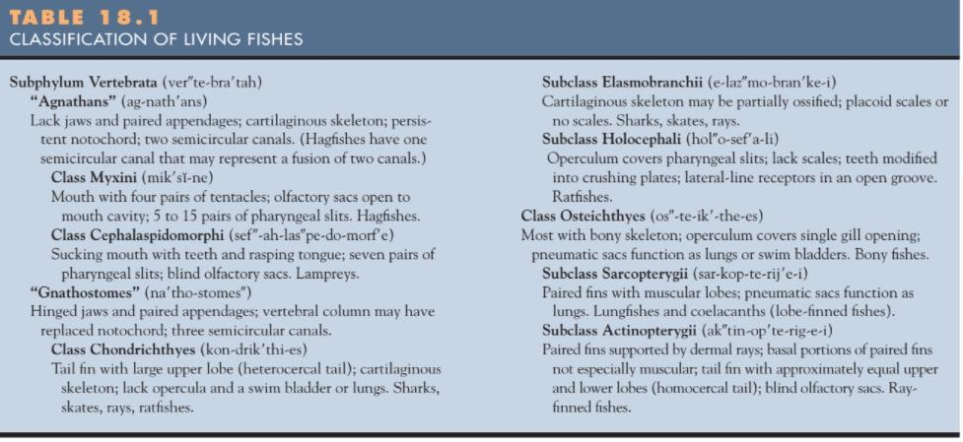
Lesson 20
Agnathans
Ostracoderms are extinct agnathans that belonged to several classes. Ostracoderms were bottom dwellers, often about 15 cm long. Most were probably filter feeders, either filtering suspended organic matter from the water or extracting annelids and other animals from muddy sediments. Some ostracoderms may have used bony plates around the mouth in a jawlike fashion to crack gastropod shells or the exoskeletons of arthropods

Class Myxini
Hagfishes are members of the class Myxini. Hagfishes live buried in the sand and mud of marine environments, where they feed on soft-bodied invertebrates and scavenge dead and dying fish (Figure 18.5). When hagfishes find a suitable fish, they enter the fish through the mouth and eat the contents of the body, leaving only a sack of skin and bones. Most zoologists now consider the hagfishes to be the most primitive group of vertebrates.

Lesson 21

Class Cephalaspidomorphi
Lampreys are agnathans in the class. They are common inhabitants of marine and freshwater environments in temperate regions. Most adult lampreys prey on other fishes, and the larvae are filter feeders. The mouth of an adult is sucker like and surrounded by lips that have sensory and attachment functions. Numerous epidermal teeth line the mouth and cover a movable tongue like structure (Figure 18.6). Adults attach to prey with their lips and teeth and use their tongues to rasp away scales. Lampreys have salivary glands with anticoagulant secretions and feed mainly on the blood of their prey. Some lampreys, however, are not predatory.
Members of the genus Lampetra are called brook lampreys. The larval stages of brook lampreys last for about three years, and the adults neither feed nor leave their stream. They reproduce soon after metamorphosis and then die. Adult sea lampreys live in the ocean or the Great Lakes. Near the end of their lives, they migrate—sometimes hundreds of miles—to a spawning bed in a freshwater stream. Once lampreys reach their spawning site, usually in relatively shallow water with swift currents, they begin building a nest by making small depressions in the substrate. When the nest is prepared, a female usually attaches to a stone with her mouth. A male uses his mouth to attach to the female’s head and wraps his body around the female. Eggs are shed in small batches over a period of several hours, and fertilization is external. The relatively sticky eggs are then covered with sand.
Eggs hatch in approximately three weeks into ammocoete larvae. The larvae drift downstream to softer substrates, where they bury themselves in sand and mud and filter feed in a fashion similar to amphioxus. Ammocoete larvae grow from 7 mm to about 17 cm over three years. During later developmental stages, the larvae metamorphose to the adult over a period of several months. The mouth becomes suckerlike, and the teeth, tongue, and feeding musculature develop. Lampreys eventually leave the mud permanently and begin a journey to the sea to begin life as predators. Adults return only once to the headwaters of their stream to spawn and die.

Lesson 22 GNATHOSTOMES
Two major developments in vertebrate evolution were the appearance of jaws and paired appendages. Jaws are used in feeding and are partly responsible for a transition to more active, predatory lifestyles. Pectoral fins of fishes are appendages usually just behind the head, and pelvic fins are usually located ventrally and posteriorly. Both sets of paired fins give fishes a more precise steering mechanism and increase fish agility.
Two classes of gnathostomes still have living members: the cartilaginous fishes (class Chondrichthyes) and the bony fishes (class Osteichthyes). Another class, the armored fishes, or placoderms, contained the earliest jawed fishes. They are now extinct and apparently left no descendants. A fourth group of ancient, extinct fishes, the acanthodians, may be more closely related to the bony fishes.

Class Chondrichthyes
Members of the class Chondrichthyes include the sharks, skates, rays, and ratfishes (see table 18.1). Most chondrichthians are carnivores or scavengers, and most are marine. In addition to their biting mouthparts and paired appendages, chondrichthians possess epidermal placoid scales and a cartilaginous endoskeleton. The subclass Elasmobranchii (e-lazmo-branke-i) (Gr. elasmos, plate metal branchia, gills), which includes the sharks, skates, and rays, has about seven hundred species (Figure 18.9). Sharks arose from early jawed fishes midway through the Devonian period, about 375 million years ago. The absence of certain features characteristic of bony fishes (e.g., a swim bladder to regulate buoyancy, a gill cover, and a bony skeleton) is sometimes interpreted as evidence of the primitiveness of elasmobranchs. This interpretation is mistaken, as these
characteristics simply resulted from different adaptations in the two groups to similar selection pressures. Some of these adaptations are described later in this chapter.
Tough skin with dermal, placoid scales covers sharks (Figure 18.10a). These scales project posteriorly and give the skin a tough, sandpaper texture. (In fact, dried shark skin has been used for sandpaper.) Posteriorly pointed scales also reduce friction with the water as a shark swims. Shark teeth are actually modified placoid scales. The largest sharks are not predatory but are filter feeders. They have pharyngeal-arch modifications that strain plankton. The fiercest and most feared sharks are the great white shark (Carcharodon) and the mako (Isurus). Skates and rays are specialized for life on the ocean floor.

They usually inhabit shallow water, where they use their blunt teeth to feed on invertebrates. Their most obvious modification for life on the ocean floor is a lateral expansion of the pectoral fins into wing like appendages. Locomotion results from dorsoventral muscular waves that pass posteriorly along the finsThe sting ray (Dasyatis) has a tail modified into a defensive lash; the dorsal fin persists as a venomous spine. Also included in this group are the electric rays (Narcine and Torpedo) and manta rays (Manta) (see figure 18.9b).
A second major group of chondrichthians, in the subclass Holocephali contains about 30 species. A frequently studied example, Chimaera, has a large head with a small mouth surrounded by large lips. A narrow, tapering tail has resulted in the common name “ratfish.” Holocephalans diverged from other chon- drichthians nearly 300 million years ago. Holocephalans lack scales.

Lesson 23
Class Osteichthyes
Members of the class Osteichthyes characterized by having at least some bone in their skeleton and/or scales, bony operculum covering the gill openings, and lungs or a swim bladder. Any group that has at least 20,000 species and is a major life-form in most of the earth’s vast aquatic habitats
must be judged very successful from an evolutionary perspective. The first fossils of bony fishes are from late Silurian deposits (approximately 405 million years old). By the Devonian period (350 million years ago), the two subclasses were in the midst of their adaptive radiations (see table 18.1; see also figure 18.3). Members of the subclass Sarcopterygii have muscular lobes associated with their fins and usually use lungs in gas exchange. One group of sarcoptery gians are the lungfishes. Only three genera survive today, and all live in regions where seasonal droughts are common. When freshwater lakes and rivers begin to stagnate and dry, these fishes use lungs to breathe air. Some (Neoceratodus) inhabit the freshwaters of Queensland, Australia. They survive stagnation by breathing air, but they normally use gills and cannot withstand total drying.
Others are found in freshwater rivers and lakes in tropical Africa (Protopterus) and tropical South America (Lepidosiren). They can survive when rivers or lakes are dry by burrowing into the mud. They keep a narrow air pathway open by bubbling air to the surface. After the substrate dries, the only evidence of a lungfish burrow is a small opening in the earth. Lungfishes may remain in aestivation for six months or more. (Aestivation is a dormant state that helps an animal withstand hot, dry periods.) When rain again fills the lake or riverbed, lungfishes emerge from their burrows to feed and reproduce.
A second group of sarcopterygians are the coelacanths. The most recent coelacanth fossils are over 70 million years old. It is large—up to 80 kg—and has heavy scales. Ancient coelacanths lived in freshwater lakes and rivers; thus, the ancestors of Latimeria must have moved from freshwater habitats to the deep sea. A third group of sarcopterygians, called osteolepiforms, became extinct before the close of the Paleozoic period. They are believed to have been the ancestors of ancient amphibians.
The subclass Actinopterygii contains fishes that are sometimes called the ray-finned fishes because their fins lack muscular lobes. They usually possess swim bladders, gas-filled sacs along the dorsal wall of the body cavity that regulate buoyancy. Zoologists now realize that there have been many points of divergence in the evolution of the Actinopterygii. One modern classification system divides the Actinopterygii into two infraclasses.

Lesson 24 Chondrosteans
One group of actinopterygians, the chondrosteans, contains many species that lived during the Permian, Triassic, and Jurassic periods (215 to 120 million years ago), but only 25 species remain today. Ancestral chondrosteans had a bony skeleton, but living members, the sturgeons and paddlefishes, have cartilaginous skeletons. Chondrosteans also have a tail with a large upper lobe. Most sturgeons live in the sea and migrate into rivers to breed (figure 18.13a). (Some sturgeons live in freshwater but maintain the migratory habits of their marine relatives.) They are large (up to 1,000 kg), and bony plates cover the anterior portion of the body. Heavy scales cover the tail. The sturgeon mouth is small, and jaws are weak. Sturgeons feed on invertebrates that they stir up from the sea or riverbed using their snouts. Because sturgeons are valued for their caviar (eggs), they have been severely overfished.
Paddlefishes are large, freshwater chondrosteans. They have a large, paddlelike rostrum that is innervated with sensory organs believed to detect weak electrical fields (figure 18.13b). They swim through the water with their large mouths open, filtering crustaceans and small fishes. They are found mainly in lakes and large rivers of the Mississippi River basin and are also known from western North America and China.
The second group of actinopterygians (Neopterygii) flourished in the Jurassic period and succeeded most chondrosteans. Two very primitive genera occur in temperate to warm freshwaters of North America. Lepisosteus, the garpike, has thick scales and long jaws that it uses to catch fishes. Amia is commonly referred to as the dogfish or bowfin. Most living fishes are members of this group and are referred to as teleosts or modern bony fishes. They have a symmetrical caudal fin and a swim bladder that has lost its connection to the digestive tract. After their divergence from ancient marine actinopterygians in the late Triassic period, teleosts experienced a remarkable evolutionary diversification and adapted to nearly every available aquatic habitat. The number of teleost species exceeds 20,000.

Lesson 25
LOCOMOTION, NUTRITION AND THE DIGESTIVE SYSTEM

Locomotion
The density of the water makes movement through it difficult and costly. For a fish, however, swimming is less energetically costly than running is for a terrestrial organism. The streamlined shape of a fish and the mucoid secretions that lubricate its body surface reduce friction between the fish and the water. Water’s buoyant properties also contribute to the efficiency of a fish’s movement through the water. A fish expends little energy in support against the pull of gravity.
Fishes move through the water using their fins and body wall to push against the incompressible surrounding water. Anyone who has eaten a fish filet probably realizes that muscle bundles of most fishes are arranged in a pattern. Because these muscles extend posteriorly and anteriorly in a zigzag fashion, contraction of each muscle bundle can affect a relatively large portion of the body wall. Very efficient, fast-swimming fishes, such as tuna and mackerel, supplement body movements with a vertical caudal (tail) fin that is tall and forked. The forked shape of the caudal fin reduces surface area that could cause turbulence and interfere with forward movement.

NUTRITION AND THE DIGESTIVE SYSTEM
The earliest fishes were probably filter feeders and scavengers that sifted through the mud of ancient seafloors for decaying organic matter, annelids, molluscs, or other bottom dwelling invertebrates. Fish nutrition dramatically changed when the evolution of jaws transformed early fishes into efficient predators.
Most modern fishes are predators and spend much of their life searching for food. Their prey vary tremendously. Some fishes feed on invertebrate animals floating or swimming in the plankton or living in or on the substrate. Many feed on other vertebrates. Similarly, the kinds of food that one fish eats at different times in its life varies. For example, as a larva, a fish may feed on plankton; as an adult, it may switch to larger prey, such as annelids or smaller fish. Fishes usually swallow prey whole. Teeth capture and hold prey, and some fishes have teeth that are modified for crushing the shells of molluscs or the exoskeletons of arthropods.
To capture prey, fishes often use the suction that closing the opercula and rapidly opening the mouth creates, which develops a negative pressure that sweeps water and prey inside the mouth. Other feeding strategies have also evolved in fishes. Herring, paddlefishes, and whale sharks are filter feeders. Long gill processes, called gill rakers, trap plankton while the fish is swimming through the water with its mouth open (see figure 18.13b). Other fishes, such as carp, feed on a variety of plants and small animals. A few, such as the lamprey, are external parasites for at least a portion of their lives. A few are primarily herbivores, feeding on plants. The fish digestive tract is similar to that of other vertebrates.
An enlargement, called the stomach, stores large, often infrequent, meals. The small intestine, however, is the primary site for enzyme secretion and food digestion. Sharks and other elasmobranchs have a spiral valve in their intestine, and bony fishes possess outpockets of the intestine, called pyloric ceca, which increase absorptive and secretory surfaces.

Lesson 26 Circulation
All vertebrates have a closed circulatory system in which a heart pumps blood, with red blood cells containing hemoglobin, through a series of arteries, capillaries, and veins. The evolution of lungs in fishes was paralleled by changes in vertebrate circulatory systems. These changes are associated with the loss of gills, delivery of blood to the lungs, and separation of oxygenated and unoxygenated blood in the heart. The vertebrate heart develops from four embryological enlargements of a ventral aorta. In fishes, blood flows from the venous system through the sinus venosus, the atrium, the ventricle, the conus arteriosus, and into the ventral aorta (figure 18.15a).
Five afferent vessels carry blood to the gills, where the vessels branch into capillaries. Blood is collected by efferent vessels, delivered to the dorsal aorta, and distributed to the body. Even though lungfishes are not a transitional group, they provide a good example of how lungs alter the circulatory pattern.
Circulation to gills continues, but a vessel to the lungs has developed as a branch off aortic arch VI (figure 18.15b). This vessel is now called the pulmonary artery. Blood from the lungs returns to the heart through pulmonary veins and enters the left side of the heart. The atrium and ventricle of the lungfish heart are partially divided. These partial divisions help keep unoxygenated blood from the body separate from the oxygenated blood from the lungs. A spiral valve in the conus arteriosus helps direct blood from the right side of the heart to the pulmonary artery and blood from the left side of the heart to the remaining aortic arches.
Thus, the lungfishes show a distinction between a pulmonary circuit and a systemic circuit.

Lesson 27 Gas Exchange
Fishes live in an environment that contains less than 2.5% of the oxygen present in air. To maintain adequate levels of oxygen in their bloodstream, fishes must pass large quantities of water across gill surfaces and extract the small amount of oxygen present in the water.
Most fishes have a muscular pumping mechanism to move the water into the mouth and pharynx, over the gills, and out of the fish through gill openings. Muscles surrounding the pharynx and the opercular cavity, which is between the gills and the operculum, power this pump. Some elasmobranchs and open-ocean bony fishes, such as the tuna, maintain water flow by holding their mouths open while swimming. This method is called ram ventilation. Elasmobranchs do not have opercula to help pump water, and therefore, some sharks must keep moving to survive. Others move water over their gills with a pumping mechanism similar to that just described. Rather than using an operculum in the pumping process, however, these fishes have gill bars with external flaps that close and form a cavity functionally similar to the opercular cavity of other fishes. Spiracles are modified pharyngeal slits that open just behind the eyes of elasmobranchs and are used as an alternate route for water entering the pharynx.
Gas exchange across gill surfaces is very efficient. Gill (visceral) arches support gills. Gill filaments extend from each gill arch and include vascular folds of epithelium, called pharyngeal lamellae (figure 18.16a,b). Branchial arteries carry blood to the gills and into gill filaments. The arteries break into capillary beds in pharyngeal lamellae. Gas exchange occurs as blood and water move in opposite directions on either side of the lamellar epithelium. This countercurrent exchange mechanism provides very efficient gas exchange by maintaining a concentration gradient between the blood and the water over the entire length of the capillary bed (figure 18.16c,d).

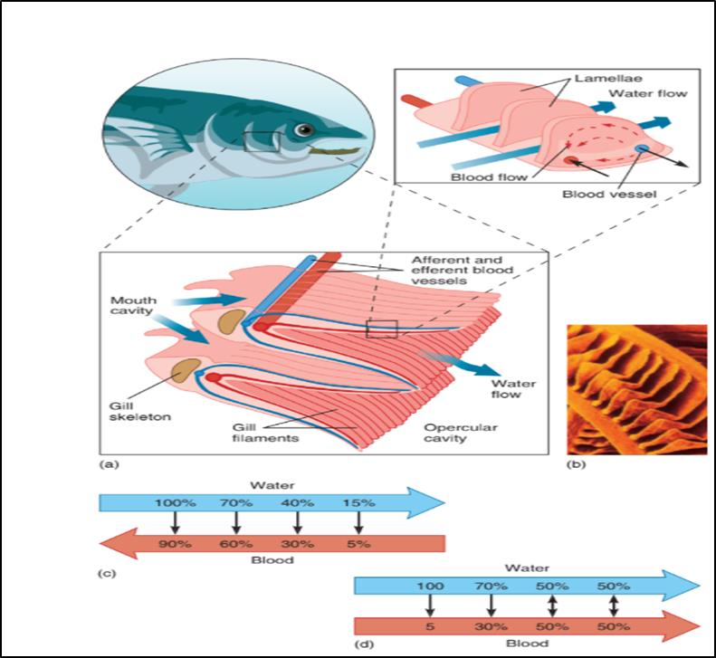

Figure 18.16: Gas Exchange at the Pharyngeal Lamellae. (a) The gill arches under the operculum support two rows of gill filaments. Blood flows into gill filaments through afferent branchial arteries, and these arteries break into capillary beds in the pharyngeal lamellae. Water and blood flow in opposite directions on either side of the lamellae. (b) Electron micro-graph of the tip of a trout gill filament, showing numerous lamellae. (c, d) A comparison of countercurrent and parallel exchanges. Water entering the spaces between pharyngeal lamellae is saturated with oxygen in both cases. In countercurrent exchange (c), this water encounters blood that is almost completely oxygenated, but a diffusion gradient still favors the movement of more oxygen from the water to the blood. As water continues to move between lamellae, it loses oxygen to the blood because it is continually encountering blood with a lower oxygen concentration. Thus, a diffusion gradient is maintained along the length of the lamellae. If blood and water moved in parallel fashion (d), oxygen would diffuse from water to blood only until the oxygen concentration in blood equaled the oxygen concentration in water, and the exchange would be much less efficient.

Lesson 28
Swim Bladders and Lungs
The Indian climbing perch spends its life almost entirely on land. These fishes, like most bony fishes, have gas chambers called pneumatic sacs. In nonteleost fishes and some teleosts, a
pneumatic duct connects the pneumatic sacs to the esophagus or another part of the digestive tract. Swallowed air enters these sacs, and gas exchange occurs across vascular surfaces. Thus, in the Indian climbing perch, lungfishes, and ancient rhipidistians, pneumatic sacs function(ed) as lungs. In other bony fishes, pneumatic sacs act as swim bladders.
Most zoologists believe that lungs are more primitive than swim bladders. Much of the early evolution of bony fishes occurred in warm, freshwater lakes and streams during the Devonian period. These bodies of water frequently became stagnant and periodically dried. Having lungs in these habitats could have meant the difference between life and death. On the other hand, later evolution of modern bony fishes occurred in marine and freshwater environments, where stagnation was not a problem. In these environments, the use of pneumatic sacs in buoyancy regulation would have been adaptive (figure 18.17).

Buoyancy Regulation
Fishes maintain their vertical position in a column of water in one or more of four ways. One way is to incorporate low-density compounds into their tissues. Fishes (especially their livers) are saturated with buoyant oils. A second way fishes maintain vertical position is to use fins to provide lift. The pectoral fins of a shark are planing devices that help to create lift as the shark moves through the water. Also, the large upper lobe of a shark’s caudal fin provides upward thrust for the posterior end of the body (see figure 18.9a). A third adaptation is the reduction of heavy tissues in fishes. The bones of fishes are generally less dense than those of terrestrial vertebrates. One of the adaptive features of the elasmobranch cartilaginous skeleton probably results from cartilage being only slightly heavier than water. The fourth adaptation is the swim bladder. A fish regulates buoyancy by precisely controlling the volume of gas in its swim bladder.
The pneumatic duct connects the swim bladders of garpike, sturgeons, and other primitive bony fishes to the esophagus or another part of the digestive tract. These fishes gulp air at the surface to force air into their swim bladders.
Most teleosts have swim bladders that have lost a functional connection to the digestive tract. The blood secretes gases (various mixtures of nitrogen and oxygen) into the swim bladder using a countercurrent exchange mechanism in a vascular network called the rete mirabile (“miraculous net’’). Gases may be reabsorbed into the blood at the posterior end of the bladder, the ovale (see figure 18.17c).
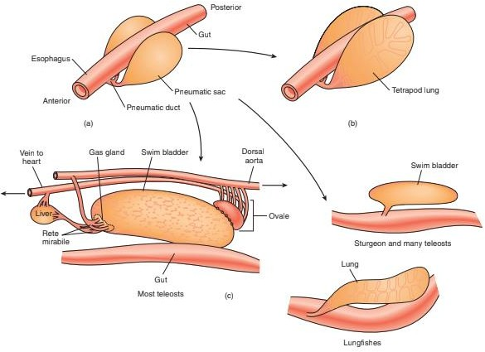

Figure 18.17: Possible Sequence in the Evolution of Pneumatic Sacs. (a) Pneumatic sacs may have originally developed from ventral outgrowths of the esophagus. Many ancient fishes probably used pneumatic sacs as lungs. (b) Primitive lungs developed further during the evolution of vertebrates. Internal compart- mentalization increases surface area for gas exchange in land vertebrates. (c) In most bony fishes, pneumatic sacs are called swim bladders, and they are modified for buoyancy regulation. Swim bladders are dorsal in position to prevent a tendency for the fish to “belly up’’ in the water. Pneumatic duct connections to the esophagus are frequently lost, and gases transfer from the blood to the swim bladder through a countercurrent exchange mechanism called a rete mirabile. The ovale, at the posterior end of the swim bladder, returns gases to the bloodstream.

Lesson 29
Nervous system and sensory function
The central nervous system of fishes, as in other vertebrates, consists of a brain and a spinal cord. Sensory receptors are widely distributed over the body. In addition to generally distributed receptors for touch and temperature, fishes possess specialized receptors for olfaction, vision, hearing, equilibrium and balance, and for detecting water movements. Openings, called external nares, in the snouts of fishes lead to olfactory receptors. In most fishes, receptors are in blind- ending olfactory sacs. In a few fishes, the external nares open to nasal passages that lead to the mouth cavity. Recent research has revealed that some fishes rely heavily on their sense of smell. For example, salmon and lampreys return to spawn in the streams in which they hatched years earlier. Their migrations to these streams often involve distances of hundreds of kilometers, and the fishes’ perception of the characteristic odors of their spawning stream guide them. The eyes of fishes are similar in most aspects of structure to those in other vertebrates. They are lidless, however, and the lenses are round. Focusing requires moving the lens forward or backward in the eye. (Most other vertebrates focus by changing the shape of the lens.) Receptors for equilibrium, balance, and hearing are in the inner ears of fishes, and their functions are similar to those of other vertebrates. Semicircular canals detect rotational movements, and other sensory patches help with equilibrium and balance by detecting the direction of the gravitational pull. Fishes lack the outer

and/or middle ear, which conducts sound waves to the inner ear in other vertebrates. Anyone who enjoys fishing knows, however, that most fishes can hear. Vibrations may pass from the water through the bones of the skull to the middle ear, and a few fishes have chains of bony ossicles (modifications of vertebrae) that connect the swim bladder to the back of the skull. Vibrations strike the fish, are amplified by the swim bladder, and sent through the ossicles to the skull. Running along each side and branching over the head of most fishes is a lateral-line system. The lateral-line system consists of sensory pits in the epidermis of the skin that connect to canals that run just below the epidermis. In these pits are receptors that are stimulated by water moving against them. Lateral lines are used to detect either water currents, or a predator or a prey that may be causing water movements, in the vicinity of the fish. Fishes may also detect low-frequency sounds with these receptors.

Electric Fishes
A U.S. Navy pilot has just ejected from his troubled aircraft over shark-infested water! What measures can the pilot take to ensure survival under these hostile conditions? The Navy has considered this scenario. One of the solutions to the problem is a polyvinyl bag suspended from an inflatable collar. The polyvinyl bag helps conceal the downed flyer from a shark’s vision and keen sense of smell. But is that all that is required to ensure protection? All organisms produce weak electrical fields from the activities of nerves and muscles. Electroreception is the detection of electrical fields that the fish or another organism in the environment generates. Electroreception and/or electrogeneration has been demonstrated in over five hundred species of fishes in seven families of Chondrichthyes and Osteichthyes. These fishes use their electroreceptive sense for detecting prey and for orienting toward or away from objects in the environment. Nowhere is prey detection with this sense better developed than in the rays and sharks. Spiny dogfish sharks, the common laboratory specimens, locate prey by electroreception. A shark can find and eat a flounder that is buried in sand, and it will try to find and eat electrodes that are creating electrical signals similar to those that the flounder emits. On the other hand, a shark cannot find a dead flounder buried in the sand or a live flounder covered by an insulating polyvinyl sheet.
Some fishes are not only capable of electroreception, but can also generate electrical currents. An electric fish (Gymnarchus niloticus) lives in freshwater systems of Africa. Muscles near its caudal fin are modified into organs that produce a continuous electrical discharge. This current spreads between the tail and the head. Porelike perforations near the head contain electroreceptors. The electrical waves circulating between the tail and the head are distorted by objects in their field. This distortion is detected in changing patterns of receptor stimulation.
The electrical sense of Gymnarchus is an adaptation to living in murky freshwater habitats where eyes are of limited value. The fishes best known for producing strong electrical currents are the electric eel (a bony fish) and the electric ray (an elasmobranch). The electric eel (Electrophorus) occurs in rivers of the Amazon basin in South America. The organs for producing electrical currents are in the trunk of the electric eel and can deliver shocks in excess of 500 volts. The electric ray (Narcine) has electric organs in its fins that are capable of producing pulses of 50 amperes at about 50 volts. Shocks that these fishes produce are sufficiently strong to stun or kill
prey, discourage large predators, and teach unwary humans a lesson that will never need to be repeated.

Lesson 30 and 31
Excretion and osmoregulation
Fishes, like all animals, must maintain a proper balance of electrolytes (ions) and water in their tissues. This osmoregulation is a major function of the kidneys and gills of fishes. Kidneys are located near the midline of the body, just dorsal to the peritoneal membrane that lines the body cavity. As with all vertebrates, the excretory structures in the kidneys are called nephrons. Nephrons filter bloodborne nitrogenous wastes, ions, water, and small or- ganic compounds across a network of capillaries called a glomerulus. The filtrate then passes into a tubule system, where essentialncomponents may be reabsorbed into the blood. The filtrate remaining in the tubule system is then excreted. Freshwater fishes live in an environment containing few dissolved substances. Osmotic uptake of water across gill, oral, and intestinal surfaces and the loss of essential ions by excretion and defecation are constant. To control excess water buildup and ion loss, freshwater fishes never drink and only take in water when feeding. Also, the numerous nephrons of freshwater fishes frequently possess large glomeruli and relatively short tubule systems.
Reabsorption of some ions and organic compounds follows filtration. Because the tubule system is relatively short, little water is reabsorbed. Thus, freshwater fishes produce large quantities of very dilute urine. Ions are still lost, however, through the urine and by diffusion across gill and oral surfaces. Active transport of ions into the blood at the gills compensates for this ion loss. Fresh water fishes also get some salts in their food (figure 18.20a).
Marine fishes face the opposite problems. Their environment contains 3.5% ions, and their tissues contain approximately 0.65% ions. Marine fishes, therefore, must combat water loss and accumulation of excess ions. They drink water and eliminate excess ions by excretion, defecation, and active transport across gill surfaces. The nephrons of marine fishes frequently possess small glomeruli and long tubule systems. Much less blood is filtered than in freshwater fishes, and water is efficiently, although not entirely, reabsorbed from the nephron (figure 18.20b). Elasmobranchs have a unique osmoregulatory mechanism. They convert some of their nitrogenous wastes into urea in the liver. This in itself is somewhat unusual, because most fishes excrete ammonia rather than urea. Even more unusual, however, is that urea is sequestered in tissues all over the body. Enough urea is stored to make body tissues isosmotic with seawater. (That is, the concentration of solutes in a shark’s tissues is essentially the same as the concentration of ions in seawater.) Therefore, the problem most marine fishes have of losing water to their environment is much less severe for elasmobranchs. Energy that does not have to be devoted to water conservation can now be used in other ways.
This adaptation required the development of tolerance to high levels of urea, because urea disrupts important enzyme systems in the tissues of most other animals. In spite of this unique adaptation, elasmobranchs must still regulate the ion concentrations in their tissues. In addition to having ion- absorbing and secreting tissues in their gills and kidneys, elasmobranchs possess a rectal gland that removes excess sodium chloride from the blood and excretes it into the cloaca. (A cloaca is a common opening for excretory, digestive, and reproductive products.) Diadromous fishes migrate between freshwater and marine environments. Salmon (e.g., Oncorhynchus) and marine lampreys (Petromyzon) migrate from the sea to freshwater to spawn, and the freshwater eel (Anguilla) migrates from freshwater to marine environments to spawn. Diadromous migrations require gills capable of coping with both uptake and secretion of ions. Osmoregulatory powers needed for migration between marine and freshwater environments may not be developed in all life-history stages. Young salmon, for example, cannot enter the sea until certain cells on the gills develop ion- secreting powers. Fishes have few problems getting rid of the nitrogenous by- products of protein metabolism. Up to 90% of nitrogenous wastes are eliminated as ammonia by diffusion across gill surfaces. Even though ammonia is toxic, aquatic organisms can have it as an excretory product because ammonia diffuses in the surrounding water. The remaining 10% of nitrogenous wastes are excreted as urea, creatine, or creatinine. These wastes are produced in the liver and are excreted via the kidneys.

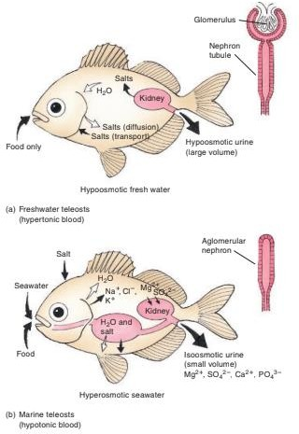
FIGURE 18.20
Osmoregulation by (a) Freshwater and (b) Marine Fishes. Large arrows indicate passive uptake or loss of water or electrolytes (ions) through ingestion and excretion. Small, solid arrows indicate active transport processes at gill membranes and kidney tubules. Small, open arrows indicate passive uptake or loss by diffusion through permeable surfaces. Insets of kidney nephrons depict adaptations within the kidney. Water, ions, and small organic molecules are filtered from the blood at the glomerulus of the nephron. Essential components of the filtrate can be reabsorbed within the
tubule system of the nephron. Marine fishes conserve water by reducing the size of the glomerulus of the nephron, and thus reducing the quantity of water and ions filtered from the blood. Other ions can be secreted from the blood into the kidney tubules. Marine fishes can produce urine that is isoosmotic with the blood. Freshwater fishes have enlarged glomeruli and short tubule systems. They filter large quantities of water from the blood, and tubules reabsorb some ions from the filtrate. Freshwater fishes produce a hypoosmotic urine.

Lesson 32 and 33
REPRODUCTION AND DEVELOPMENT
Producing overwhelming numbers of eggs, however, is not the only way that fishes increase the chances that a few of their will survive. Some fishes show mating behavior that helps ensure fertilization, or nesting behavior that protects eggs from predation, sedimentation, and fouling.
Mating may occur in large schools, and one individual releasing eggs or sperm often releases spawning pheromones that induce many other adults to spawn. Huge masses of eggs and sperm released into the open ocean ensure the fertilization of many eggs. The vast majority of fishes are oviparous, meaning that eggs develop outside the female from stored yolk. Some elasmobranchs are ovoviviparous, and their embryos develop in a modified oviduct of the female. Nutrients are supplied from yolk stored in the egg. Other elasmobranchs, including gray reef sharks and hammerheads, are viviparous. A placenta-like outgrowth of a modified oviduct diverts nutrients from the female to the yolk sacs of developing embryos. Internal development of viviparous bony fishes usually occurs in ovarian follicles, rather than in the oviduct. In guppies (Lebistes), eggs are retained in the ovary, and fertilization and early development occur there. Embryos are then released into a cavity within the ovary and development continues, with nourishment coming partly from yolk and partly from ovarian secretions.
Some fishes have specialized structures that aid in sperm transfer. Male elasmobranchs, for example, have modified pelvic fins called claspers. During copulation, the male inserts a clasper into the cloaca of a female. Sperm travel along grooves of the clasper. Fertilization occurs in the female’s reproductive tract and usually results in a higher proportion of eggs being fertilized than in external fertilization. Thus, fishes with internal fertilization usually produce fewer eggs.
In many fishes, care of the embryos is limited or nonexistent. Some fishes, however, construct and tend nests, and some carry embryos during development. Clusters of embryos may be brooded in special pouches attached to some part of the body, or they may be brooded in the mouth. Some of the best-known brooders include the seahorses (Hippocampus) and pipefishes (e.g., Syngnathus). Males of these closely related fishes carry embryos throughout development in ventral pouches. The male Brazilian catfish (Loricaria typhys) broods embryos in an enlarged lower lip. Most fishes care little, if at all, for young after hatching. Sunfishes and sticklebacks, however, provide short- term care of posthatching young. Male sticklebacks assemble fresh plant material into a mass in which the young take refuge. If one offspring wanders too far from the nest, the male snaps it up in its mouth and spits it back into the nest. Sunfish males do the same for young that wander from schools of recently hatched fish. The Cichlidae engage in longer-term care. In some species, young are mouth brooded, and other species tend young in a nest. After hatching, the young venture from
the parent’s mouth or nest but return quickly when the parent signals danger with a flicking of the pelvic fins.

